Assessment 6
L0 Final Assessment
Data Structures Coding

Name: Nisanth Saravanan
ID: 12576

Question:

Case Study: Hospital Management System

Overview: This C++ program simulates a basic hospital management system, focusing on array-based data storage and fundamental object-oriented principles. The program defines a Patient structure to organize patient information, including name, age, and diagnosis. A Hospital class encapsulates the patient management logic, utilizing a fixed-size array to store patient records. The Hospital class provides methods for

Hospital Management System:
1. Add Patient
2. Display Patients
3. Find Patient
4. Remove Patient
5. Exit

The program features a menu-driven interface, allowing users to interact with the system through console input. The program demonstrates array-based data management, basic object-oriented design, and fundamental C++ programming concepts within a simplified hospital management context.

CODE:

#include <bits/stdc++.h>
#include <string>
#include <array>

using namespace std;

//Patient Struct:
struct Patient
{
int ID;
string Name;
int Age;
string Diagnosis;

Patient() {} //Empty constructor.

Patient(int id, string name, int age, string diagnosis) //Parametrised constructor.
{
ID = id;
Name = name;
Age = age;
Diagnosis = diagnosis;
}
};

class Hospital //Class that encapsulates all the record management logics.
{
public: //Specifying access.
array<Patient, 100> AddPatient(array<Patient, 100> patients, int &n)
{
if (n > 100)
{
cout << "\n==========================" << endl;
cout << " RECORDS ARE FULL!" << endl;
cout << "==========================" << endl;
return patients;
}

cout << "\nENTER PATIENT DETAILS:" << endl;
cout << "ID: ";
int id;
cin >> id;
cout << "NAME: ";
string name;
cin.ignore();
getline(cin, name);
cout << "AGE: ";
int age;
cin >> age;
cout << "DIAGNOSIS: ";
string diagnosis;
cin.ignore();
getline(cin, diagnosis);

Patient patient = Patient(id, name, age, diagnosis);
n++;
patients[n] = patient;
cout << "PATIENT ADDED SUCCESSFULLY!" << endl;
return patients;
}

void DisplayPatient(array<Patient, 100> patients, int &n)
{
if (n == -1)
{
cout << "\n==========================" << endl;
cout << " RECORDS ARE EMPTY!" << endl;
cout << "==========================" << endl;
return;
}

cout << "\n==========================" << endl;
cout << " PATIENTS:" << endl;
cout << "==========================" << endl;
for (int i = 0; i <= n; i++)
{
cout << "\nID: " << patients[i].ID << endl;
cout << "NAME: " << patients[i].Name << endl;
cout << "AGE: " << patients[i].Age << endl;
cout << "DIAGNOSIS: " << patients[i].Diagnosis << endl;
}
}

array<Patient, 100> RemovePatient(array<Patient, 100> patients, int &n)
{
if (n == -1)
{
cout << "\n==========================" << endl;
cout << " RECORDS ARE EMPTY!" << endl;
cout << "==========================" << endl;
return patients;
}

cout << "\nENTER PATIENT ID TO REMOVE:" << endl;
int id;
cin >> id;
int index = -1;
for (int i = 0; i <= n; i++)
{
if (patients[i].ID == id)
{
index = i;
break;
}
}
if (index != -1)
{
for (int i = index; i <= n; i++)
{
patients[i] = patients[i + 1];
}
n--;
cout << "PATIENT REMOVED SUCCESSFULLY!" << endl;
return patients;
}
else
{
cout << "PATIENT NOT FOUND!" << endl;
return patients;
}
}

void FindPatient(array<Patient, 100> patients, int &n)
{
if (n == -1)
{
cout << "\n==========================" << endl;
cout << " RECORDS ARE EMPTY!" << endl;
cout << "==========================" << endl;
return;
}

cout << "\nENTER PATIENT ID TO FIND:" << endl;
int id;
cin >> id;
int index = -1;
for (int i = 0; i <= n; i++)
{
if (patients[i].ID == id)
{
index = i;
break;
}
}
if (index != -1)
{
cout << "\n==========================" << endl;
cout << " RESULTS:" << endl;
cout << "==========================" << endl;
cout << "\nID: " << patients[index].ID << endl;
cout << "NAME: " << patients[index].Name << endl;
cout << "AGE: " << patients[index].Age << endl;
cout << "DIAGNOSIS: " << patients[index].Diagnosis << endl;
}
else
{
cout << "PATIENT NOT FOUND!" << endl;
}
}
};

int main() //Driver code.
{
array<Patient, 100> patients;
Hospital hospital;
int n = -1;
int choice;

checkpoint1: //Label-Goto Mechanism.

cout << "\n==========================" << endl;
cout << "HOSPITAL MANAGEMENT SYSTEM" << endl;
cout << "==========================" << endl;
cout << "1. ADD PATIENT." << endl;
cout << "2. DISPLAY PATIENTS." << endl;
cout << "3. FIND PATIENT." << endl;
cout << "4. REMOVE PATIENT." << endl;
cout << "0. EXIT." << endl;

cout << "\nENTER YOUR CHOICE:";
cin >> choice;

switch (choice)
{
case 0:
{
cout << "\n==========================" << endl;
cout << " LOGGIN OUT!!" << endl;
cout << "==========================" << endl;
return 0;
}

default:
{
cout << "\n==========================" << endl;
cout << "INVALID CHOICE, TRY AGAIN!" << endl;
cout << "==========================" << endl;
goto checkpoint1;
}

case 1:
{
patients = hospital.AddPatient(patients, n);
goto checkpoint1;
}

case 2:
{
hospital.DisplayPatient(patients, n);
goto checkpoint1;
}

case 3:
{
hospital.FindPatient(patients, n);
goto checkpoint1;
}

case 4:
{
patients = hospital.RemovePatient(patients, n);
goto checkpoint1;
}
}
}
OUTPUT:

Adding Patients:

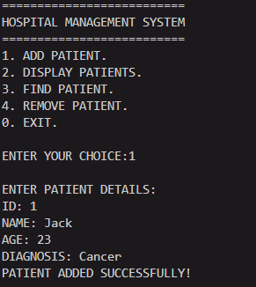

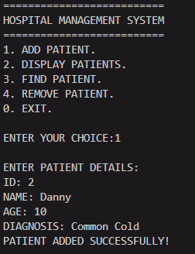

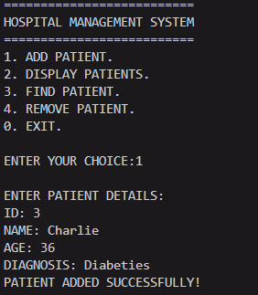

Display Patients:

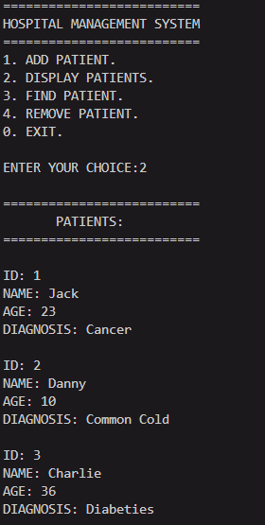
Find Patients:

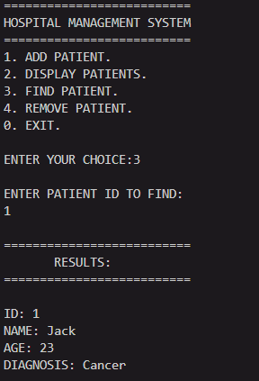

Remove Patient with verification:

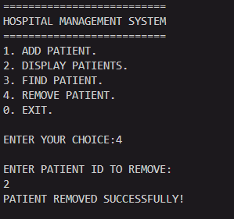

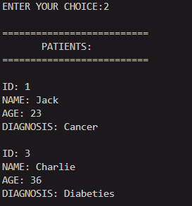

Exiting:

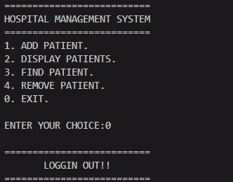

Series of invalid inputs:

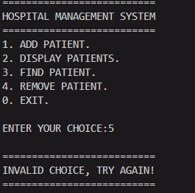

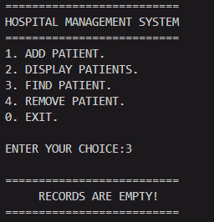 Finding.

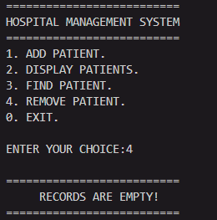 Removal.

